Trained Machine Learning Model

I established a functional relationship where a student’s participation status is predicted by numerical Independent variables. I utilized the Multiple Linear Regression model in excel for the prediction.
Dependent Variable (Y): Engagement score
Independent Variable (X): Age, Participation Frequency,$Υ =βₒ + (β₁*X₁) +(β₂*X₂)$
$Υ=Predicted value$
$βₒ=Intercept$
$X₁=Participation Frequency$
$X₂=Age$

 | Coefficients | Standard Error | t Stat | P-value | Lower 95% | Upper 95% | Lower 95.0% | Upper 95.0%
Intercept | 30.52577675 | 1.389365964 | 21.97101235 | 3.9741E-104 | 27.80228418 | 33.24926932 | 27.80228418 | 33.24926932
Participation Frequency | 5.838008229 | 0.061481334 | 94.95578398 | 0 | 5.717489979 | 5.958526479 | 5.717489979 | 5.958526479
Age | -0.068978506 | 0.055251373 | -1.24844871 | 0.211900945 | -0.177284531 | 0.039327519 | -0.177284531 | 0.039327519

Based on an analysis of 8,558 learner records, the predictive model successfully explains 51.3% of the variance in student engagement. The most critical driver of a student's engagement score is their historical Participation Frequency. For every additional instance of participation, a student's baseline engagement score increases by nearly 5.84 points, making it a highly reliable predictor ($P < 0.05).
Conversely, the analysis revealed that a student's Age is not a statistically significant predictor of engagement within this ecosystem. Returning a P-value of 0.211 (well above the standard 0.05 threshold), any minor negative impact caused by age is mathematically indistinguishable from random noise. Therefore, age demographics should not be used as a primary filtering criteria when forecasting participation
The predicted value which is a model running in the worksheet as a column titled predicted_engagement. This model will be formed by extracting the intercept values and coefficients to build my mathematical value.
Therefore, the final mathematical model will be:
=30.53 + 5.84(Participation Frequency) - 0.07(Age)
Regression Statistics
Multiple R | 0.716355683
R Square | 0.513165465
Adjusted R Square | 0.513051652
Standard Error | 22.33188801
Observations | 8558

The R Square :The independent variables explain 51% of the variation in my dependent variation. This means 51.3% of what makes a student highly engaged can be calculated entirely by tracking how many times they participate. The remaining 49% relies on outside factors not captured in this regression model

Predicted Probability
The individual learner success probabilities were aggregated to find the mathematical mean for upcoming opportunity types.
Competitions (Average: 74.95): This is the high-priority champion category. On average, students who join competitions hit an engagement level near 75 points. This means competitions strongly captivate the baseline audience.
Events (Average: 62.93) & Engagement (Average: 62.00): These sit comfortably as the steady mid-tier pipelines.
Internships (Average: 56.43): These underperform slightly compared to short-form events, likely due to structural duration gaps.
Courses (Average: 47.37): This is the true "At Risk" category. Even though Courses have the highest total count of students, their average individual engagement is the lowest at 47.37.

Row Labels | Average of predicted_engagement
Competition | 74.95
Course | 47.37
Engagement | 62.00
Event | 62.93
Internship | 56.43
Model Diagnostic and Output Visualizations
Feature Importance Chart
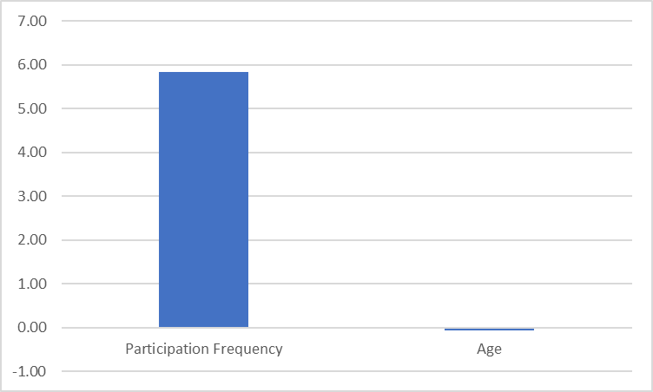
Relative weight of independent variables. Participation Frequency holds massive positive influence, whereas Age shows a negligible, slightly negative impact.

Confusion Matrix for Classification Accuracy
A new column was created in sheet 1 titled predicted_status, predicted_status = IF (predicted engagement > 50, “Active”, “Inactive”)
The predicted_status are the column counting and student status are rows counting with the learner’s key as the values. This is a Cross-tabulation of Actual vs. Predicted learner statuses based on a 50-point engagement threshold
True Negatives (3,602): The model perfectly classified 3,602 students who were completely inactive in the system.
True Positives (4,059): The model correctly captured 4,059 highly engaged, active students.
False Negatives (897): These are the "missed opportunities." The model predicted these 897 students would be inactive, but they actually turned out to be active.
False Positives (0): The matrix shows 0 inactive students misclassified as active. This indicates the model threshold is highly conservative and exceptionally safe at avoiding false optimism
Overall Model Accuracy = (True Positives + True Negatives) / Total Observation
$=_{}$(4059+ 3602) / 8558 = 89.5%

Count of LearnerKey | Column Labels
Row Labels | Active | Inactive | Grand Total
Active | 4059 | 897 | 4956
Inactive |  | 3602 | 3602
Grand Total | 4059 | 4499 | 8558

Participation Density Heatmap

Count of Participation Frequency | Column Labels
Row Labels | Long | Medium | Short | Grand Total
Competition |  | 359 |  | 359
Course | 1921 |  |  | 1921
Engagement | 126 |  |  | 126
Event |  |  | 527 | 527
Internship |  | 971 | 126 | 1097
Grand Total | 2047 | 1330 | 653 | 4030

The absolute heaviest structural concentration in the entire ecosystem is found within Courses, specifically tied to the One Time participation tier (1,921 records). This area represents the massive baseline intake of your audience, showing that long-form educational courses act as the primary funnel for student acquisition.
Short-form Events and Engagement blocks display consistent, medium-density clusters. These act as agile touchpoints that maintain weekly activity without requiring long-term student commitments.
Competitions reflect a low overall density footprint in terms of pure participation counts, yet as established in predicted probability section, they yield the highest average individual engagement (74.95).

